# Team Red Planning

Red team was given the task of creating a pamphlet about Otago polytechnics IT and business department for our client Leslie.

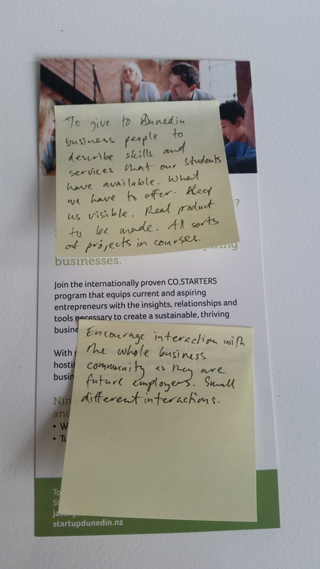Leslie has given us some details to work off.

The notes say what we need to include:

*To give to Dunedin business people to describe skills and services that our students have avalible. What we have to offer. Keep us visible. Rael product to be made. All sorts of projects in courses. Encourage interaction with the whole business community as they are future employers. Small different interactions.*

Some of the information was a bit vague so the team decided we may need more information once we got some planning done.

Our team then decided to make and split tasks between the members to finish the project quicker

James had these tasks.

1. Main coordinator
2. Designer of final draft

Tim had these tasks

1. Recourse collector/manager
2. Giving feedback on early draft

Cameron had these tasks

1. Contacting the customer
2. Giving feedback on early draft

Rory had these tasks

1. Tracking planning
2. Giving feedback on late draft

After we assigned our individual tasks we researched into what makes a good pamphlet to give us an idea of how our final design should be laid out.

Our tasks need to be complete by 29/03/2017 at 5PM